Winlink Training Bulletin #23
The Pinellas ACS Winlink training net is used to familiarize ARES®/ACS participants with Winlink skills and to practice digital network operations. A summary training bulletin is delivered via Winlink to all registered Winlink Training Net participants prior to each scheduled net. A detailed bulletin that includes instructions for performing each scheduled task will also be posted to the Pinellas ACS Web site prior to each net.

Net Description
The following information is applicable to this week’s training net.
a. Date: Wednesday February 1st, 2023
b. Time: 1930 Hours Local
c. Duration: 1 Hour
d. Type: Mixed Mode. Voice traffic will take place on the W4ACS repeater and digital exchanges will take place via Winlink.
e. Net Control: WA1RYQ
f. Support material:
(1) ICS 204 – PACS Winlink Training Group

Assignment List:
Work assignments, special instructions, and the communications plan for the net are documented in the ICS 204 for the PACS Winlink Training Group.

Net Activities:
An overview of the planned net activities is documented below.
a. The NCS will establish the net at 1930 Hours local using the W4ACS repeater.
b. The NCS will request check-ins. The NCS will include Echolink in the call for check-ins.
c. The NCS will brief net participants on the work assignments and special instructions contained in the Assignment List (ICS 204).
d. The NCS will field comments and questions about the Assignment List (ICS 204) from net participants.
e. The NCS will next direct each station to create and send a Winlink Check-In message to the NCS and the Pinellas Admin Officer.
Note: The Winlink Check-in and Check-out forms should not be completed before the net begins. Net participants should also ensure that the REQUEST MESSAGE RECEIPT box is checked on all messages.
f. The NCS will direct each station to create and send a Winlink GPS / Position Report.
g. The NCS will send a Winlink General Message (ICS 213) to all net participants.
h. Using the information contained in the Winlink General Message (ICS 213), create a new Winlink General Message (ICS 213). Once complete, send the message to all net participants.
i. The NCS will close the digital segment of the net by using a rollcall to direct each station in turn to send a Winlink Check Out message to the NCS and the Pinellas Admin Officer.
j. The NCS will field comments and questions from net participants.
k. The NCS will remind all net participants to finalize their ICS 214 and ICS 309 and send a copy to the NCS and the Pinellas ACS Admin officer following net closure.
l. Following the question-and-answer period, the NCS will close the net.

END SUMMARY WINLINK BULLETIN

Message Information:

Winlink Check-in Form:
When the net control station is ready to begin taking Winlink Check-ins, the NCS will request that each station create and send a Winlink Check-in message.
a. Group Name: PACS Winlink Training Net
b. Date/Time: This value should correspond to the time and date that the message is sent. Therefore, the Check-in message cannot be created ahead of time and stored as a draft.
c. Status: NET
d. Band: Enter the appropriate value.
e. Mode: Enter the appropriate value.
f. Send To: Send completed message to the NCS and the Pinellas Admin Officer.
g. Calls Signs of Initial On-Site Operator(s): Enter your FCC Call sign
h. Station Contact Name: Enter your first and last name
i. Station Call sign: Enter your FCC Call Sign.
j. Location: Enter a street address for your current location.
k. LAT, LONG, MGRS, GRID: Enter your current latitude, longitude, MGRS and Maidenhead grid data.
l. Comments: Weather conditions at your current location.

Winlink Check-Out form:
When the business of the net is complete, the NCS will request that each station create and send a Winlink Check-out message.
a. Group Name: PACS Winlink Training Net
b. Date/Time: This value should correspond to the time and date that the message is sent. Therefore, the Check-in message cannot be created ahead of time and stored as a draft.
c. Status: NET
d. Band: Enter the appropriate value.
e. Mode: Enter the appropriate value.
f. Send To: Send completed message to the NCS and the Pinellas Admin Officer.
g. Calls Signs of Initial On-Site Operator(s): Enter your FCC Call sign
h. Station Contact Name: Enter your first and last name
i. Station Call sign: Enter your FCC Call Sign.
j. Location: Enter a street address for your current location.
k. LAT, LONG, MGRS, GRID: Enter your current latitude, longitude, MGRS and Maidenhead grid data.
l. Comments: Version of Winlink Express and Winlink Templates.

GPS/Position Report
Winlink units can report their current position to the Winlink system. Once reported, the Winlink Common Message Server (CMS) displays the report on a position map located on Winlink’s web site and forwards the data to the Automatic Packet Reporting System-Internet System (APRS-IS). Anyone with internet access can view these position reports. APRS® applications will display Winlink position reports using the symbol.
a. From the Winlink Settings menu, select “GPS / Position Reports…”. Refer to Figure 1.
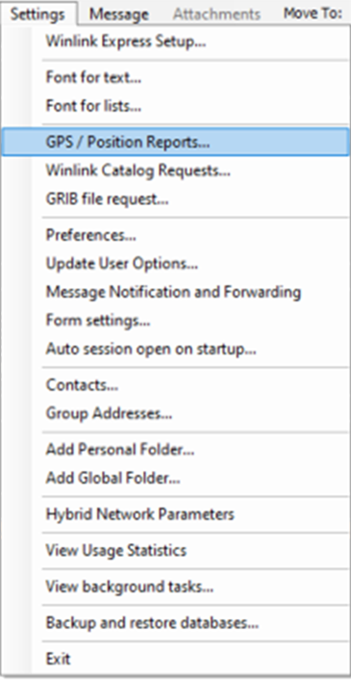
Figure 1. Winlink Settings Menu

b. Once selected, the menu shown in Figure 2 will be displayed.
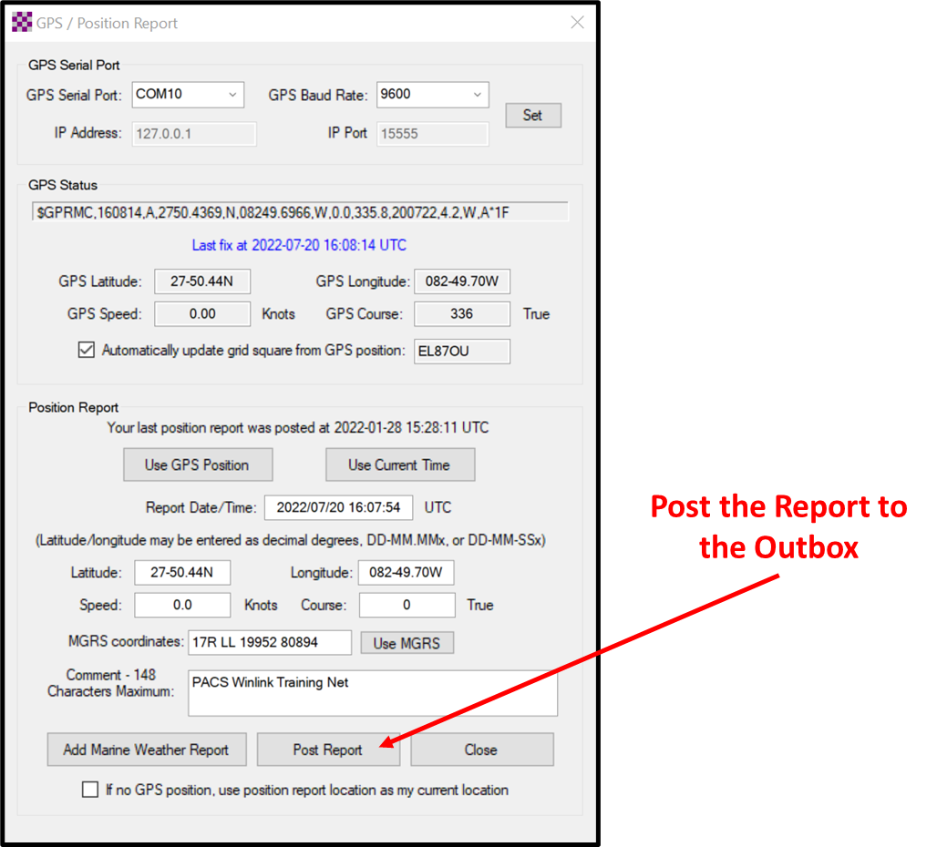
Figure 2. Winlink GPS Position Report Screen

NOTE: Winlink Express can be configured to import NMEA 0183 formatted GPS data through a serial COM port. Once configured, the time and position data needed to create a GPS position report will be automatically available for use in the report. If a GPS is not connected to the Winlink computer, time and position data will need to be entered into the report manually.
c. The following information should be entered into the report.
(1) Report Date/Time: Universal Coordinated Time (UTC)
(2) Longitude
(3) Latitude
(4) Comments: PACS Winlink Training Net
d. Post the report to the Winlink Outbox and then send the report.

EXERCISE Formatting
To become proficient at both creating and exchanging formal written traffic, ACS/ARES® will schedule and perform a variety of Drills, Functional Exercises, Full-Scale Exercises, and ARRL® Simulated Emergency Tests. During these training events, it is important that the messages generated and exchanged closely mirror those that users will likely encounter during a real activation event. However, it is just as important to ensure that no one mistakes a message generated during a training event as a report associated with a real-world emergency.
Figure 3 illustrates the proper way to format an ICS 213 EXERCISE message within Winlink.
a. Block 1 Incident Name: The first word of the incident - EXERCISE.
b. Block 4 Subject: The first word of the subject line – EXERCISE.
c. Block 7 Message: The first and last word of the message – EXERCISE.
Figure 4 illustrates an ICS 213 EXERCISE message that is ready for posting to the outbox.
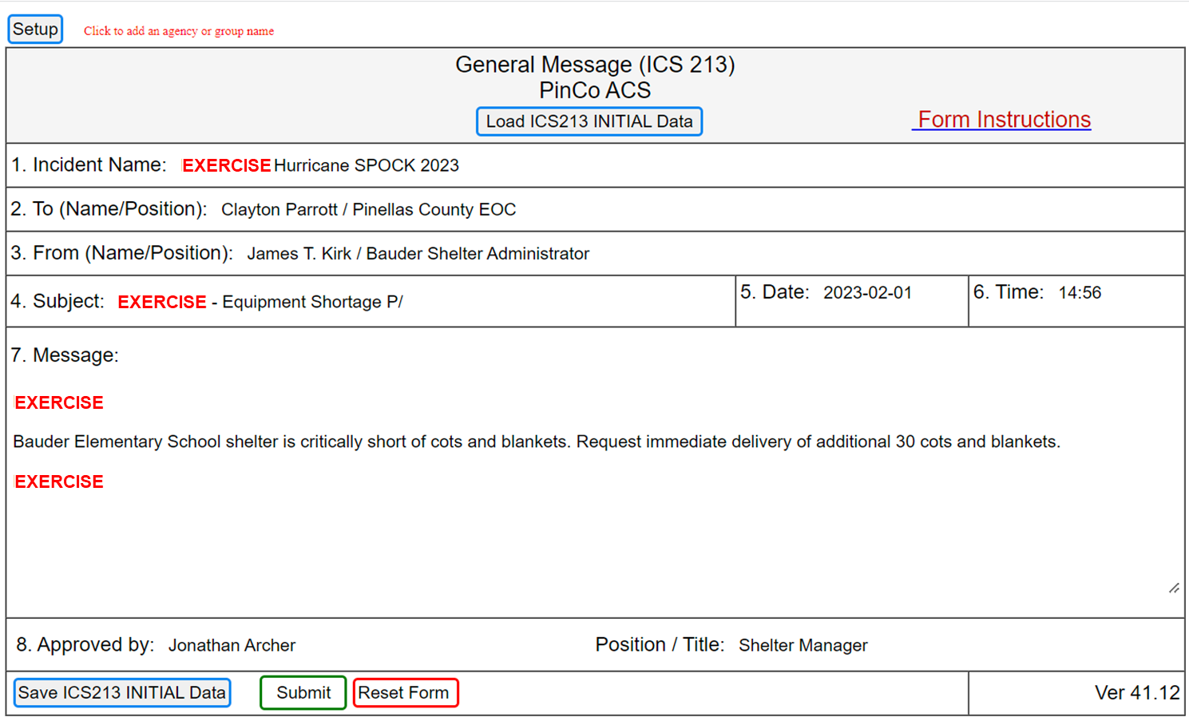
Figure 3. ICS 213 Exercise Formatting

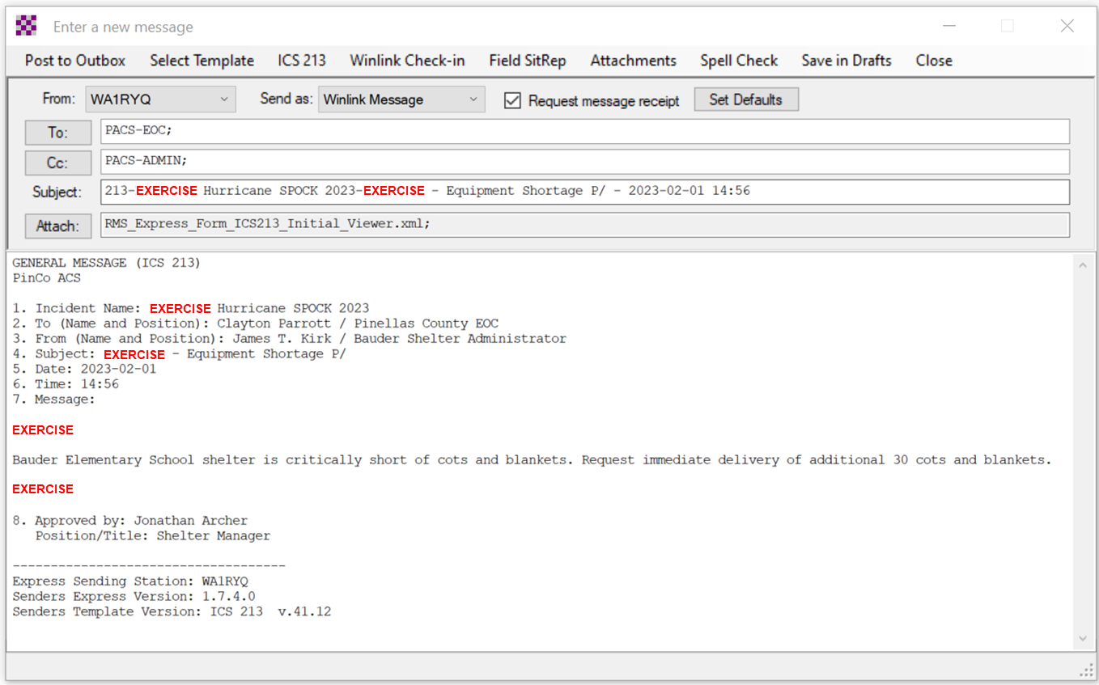
Figure 4. Winlink ICS 213 Exercise Message

Configure Winlink to annotate Priority, Immediate, and Flash messages.
Message traffic with a precedence of Priority, Immediate, or Flash must be rapidly identified and processed as soon as possible. However, during an activation event, users may encounter a high traffic volume and find it difficult to quickly identify traffic with a high priority precedence. To assist users with the identification of high priority traffic, Winlink can be configured to highlight and sound an audible alarm upon receipt of a Priority, Immediate, or Flash message.
a. Use the “Message Notification and Forwarding” option on the Settings pull-down menu to configure Winlink to make a sound when a message is received that has a precedence of Priority of higher. Refer to Figure 5.
b. Select a “New message notification sound” and configure Winlink to repeat the sound until the message is read.
NOTE: A notification sound must be selected for Winlink to properly annotate high priority messages. If the notification sound is set to None, messages will not be highlighted.
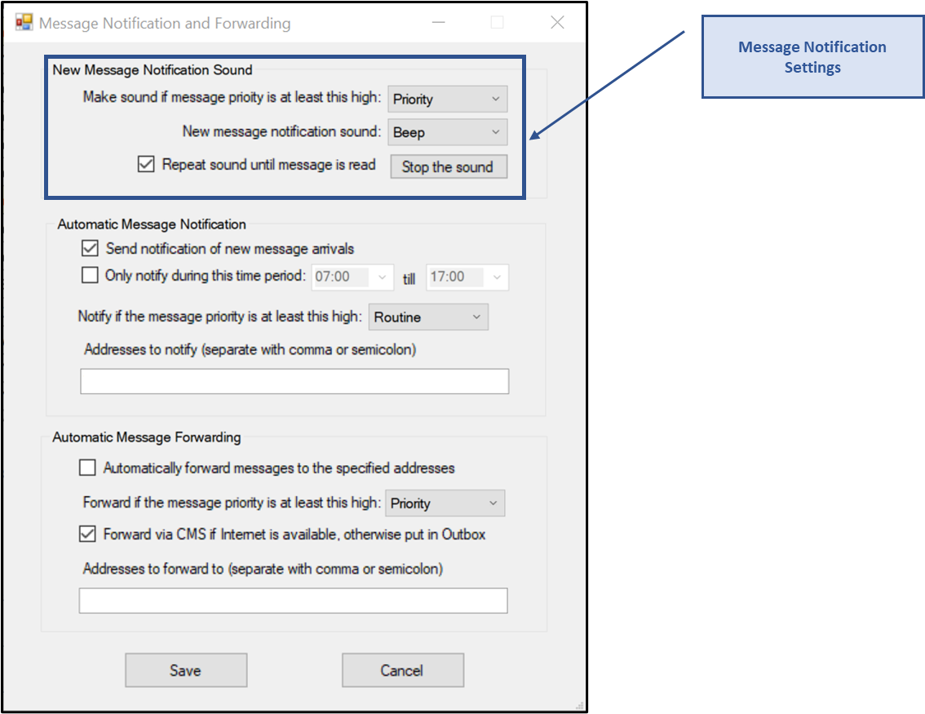
Figure 5. Message Notification Settings

Message Precedence
During an activation event, prioritizing the flow of information is a critical component of information management. Precedence is the message attribute that enables a user to prioritize each message properly.
Four precedence levels are defined within Winlink. Messages generated by ACS/ARES® will only be assigned a Winlink precedence of ROUTINE, PRIORITY, or IMMEDIATE. Under no circumstances will any message be assigned a Winlink precedence of FLASH. When creating a new message, Table I should be used to identify the Winlink precedence that corresponds to the appropriate ARRL® NTS™ precedence definition.
NOTE: A space character must proceed to precedence flag in the subject line.
Good: Subject: this is a test message P/
Bad: Subject: this is a test messageP/
For additional information about message precedence, refer to paragraph 5.1.2 of the Pinellas County ACS/ARES® Emergency Communication Plan and Standard Operating Procedures document.
Table I. WINLINK Message Precedence
Winlink Precedence | ARRL® NTS™ Precedence | SUBJECT LINE Priority Indicator | Notes
FLASH (Z) | N/A | Z/ | DO NOT USE
IMMEDIATE (O) | EMERGENCY | O/
PRIORITY (P) | PRIORITY | P/
ROUTINE (R) | ROUTINE | R/ | Default for all messages

